Bulk Georeferencing and Spatial Reference Scripts

A toolbox of Arcpy scripts for ArcGIS 10.1 or higher

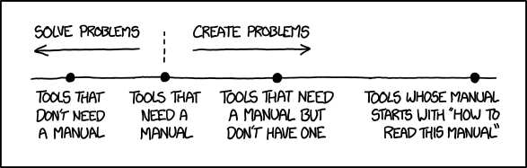

*http://xkcd.com/1343/*

Brian Bancroft, CD, B.Sc.

Contract GIS Library Technician

University of Ottawa

March 2014

# Table of Contents

[Table of Contents 1](#_Toc386178624)

[Introduction 2](#_Toc386178625)

[Software Requirements 2](#_Toc386178626)

[Software Installation 2](#_Toc386178627)

[Index File Instructions 3](#_Toc386178628)

[Creating a new spreadsheet in the index workbook 4](#_Toc386178629)

[Field Descriptions 6](#_Toc386178630)

[Installing and using the Scripts through ArcGIS 7](#_Toc386178636)

[Using the Scripts 8](#_Toc386178637)

[Z. Append Raster Files to follow uOttawa Library Nomenclature (use before Excel Indexing) 8](#_Toc386178638)

[1. Georeference and Index 9](#_Toc386178639)

[B. Generic Georeference and Index 10](#_Toc386178640)

[A. Create/Append a Spatial Footprint File Only 11](#_Toc386178641)

[Frequently Asked Questions 12](#_Toc386178642)

[About the Scripts 12](#_Toc386178643)

# Introduction

This toolset exists for libraries with large amounts of scanned maps. This tool assists through indexing, georeferencing, packaging with metadata into a .zip file (zipping). These tools are intended for when manual georeferincing and zipping is too cumbersome. This script only georeferences images that have no border and where the latitudes and longitudes of each corner are defined.

## Software Requirements

* ArcGIS 10.1 or higher
* XLRD, XLWT, Zipfile (included in the package)

# Software Installation

The ArcGIS installation should also have installed a copy of Python 2.7. The Python directory is by default “C:\Python27\ArcGIS10.1\”, and may be different depending on the version of ArcGIS used. If this directory is missing, you may require re-installing ArcGIS.

All python extensions are included in the software and can be found in the *Requisite Py Modules* directory. Look for the file named *instalModules.bat* and double-click to start the installation process.

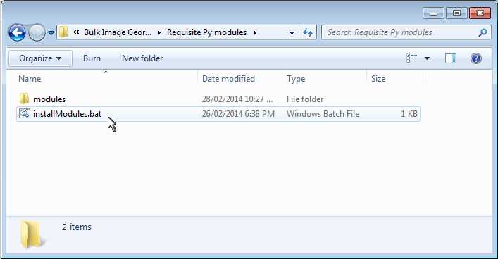

# Index File Instructions

Machine generated alternative text: Name Date modified Type Size
1J Template_Index.xlsx 10)03/2014 3:15 PM Microsoft Excel W... la KB

The index file is a Microsoft Excel workbook that is the backbone of this scripting tool. To use the tool, you will need to put the file name and the coordinates in a worksheet. The file is integral to the scripts and requires the information in specific columns. **Do not add, change the order or remove any columns before position “O” under any circumstances.**

The template file comes two worksheets, a template and an annotated example. The annotated example demonstrates the proper usage of this file. At any point, anyone can delete this worksheet in the workbook with no adverse effects.

## 

## Creating a new spreadsheet in the index workbook

To create a new spreadsheet, right click on the “Template” tab, and then click on **"**Move or Copy".

Machine generated alternative text: Insert...
Delete
Rename
Move or Copy...
c3 View Code
Protect Sheet...
lab Color
Hide
Select All Sheets
t_L 1901f TenqL,,[,.
a

First, click on the "Create a copy" checkbox. Select which sheet you wish your new sheet to appear on by clicking on that sheet in the "Before Sheet" box below:

Machine generated alternative text: MoveorCopy []J[J
Move selected sheets
lo book:
Template ndex.xlsx ZIEl
Before sheet:
1901
(move to end)
R1 Çreate a copy,
OK Cancel

Right-click on the new sheet and select "**Rename**" to change the tab to a year

Machine generated alternative text: bi1 1901 ‘ TempIateI2LIemola .. bI [ 1901 1 1945 ., / Tempbte 
- 1
Move or Copy...
View Code
Protect Sheet...
lab Color b
Hide
Select All Sheets

## Field Descriptions

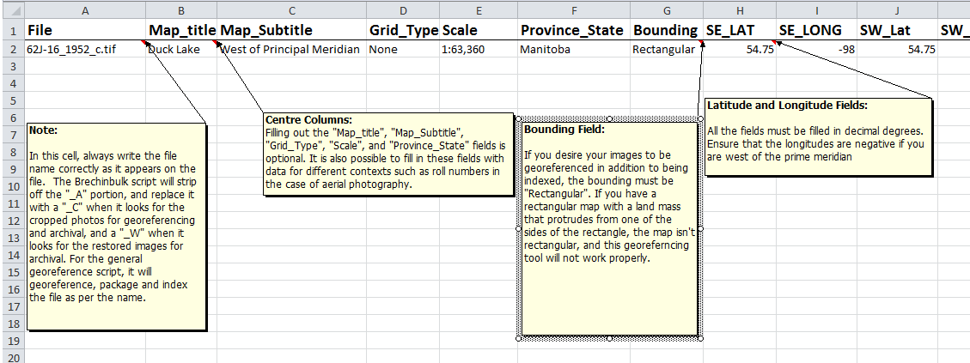

### The “File” Field (mandatory)

The file field is reserved for the filename of the image you wish to index. Ensure that the filename is written exactly as it appears in windows explorer. Do not forget to include the file extension such as “.tif”.

### The “Map\_title”, “Map\_subtitle”, “Grid\_Type”, “Scale”, and “Province\_State” fields

### These fields were designed with topographic maps in mind, but can be used for any text information. If you are using aerial photography, roll numbers and flight lines can be substituted.

### The “Bounding” field (mandatory)

This field determines whether the file can be georeferenced. If you have an airphoto or map that is perfectly rectangular, select in “Rectangular” from the drop-down list. If the map’s bounding isn’t rectangular, “Irregular” must be selected, as this tool cannot georeference such maps.

### The Latitude and Longitude Fields (mandatory)

These fields are where you put in the latitude and longitude in Decimal Degrees. If you are west of the prime meridian, remember that longitude values are negative!

# Installing and using the Scripts through ArcGIS

After you unpackage the script in a directory, open ArcGIS. Start a new file or open an existing .mxd file. Open the ArcToolbox window

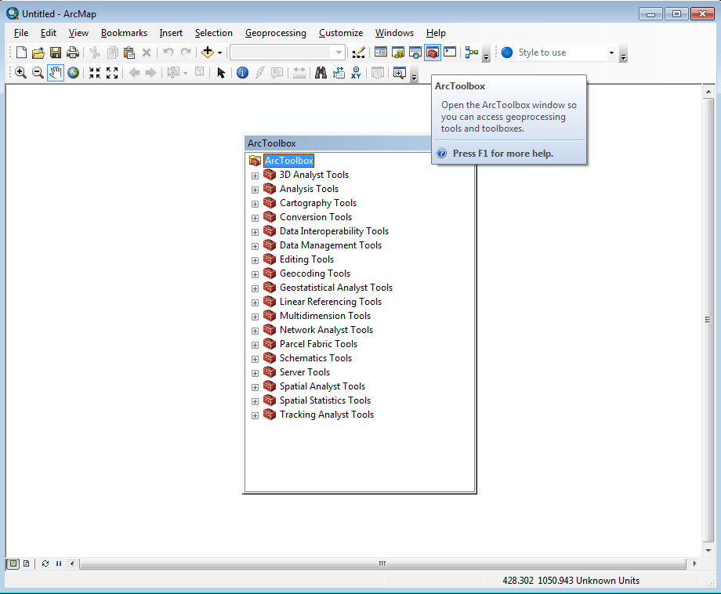

Right-click on the white space in the ArcToolbox window and select “Add Toolbox”. A prompt will guide you for the new toolbox. If you are unable to find the folder that contains the toolbox, click on the “Connect to Folder” icon that is fourth from the right in the upper icons. Doing so helps you to find the folder which contains the toolbox. Select the toolbox and press OK.

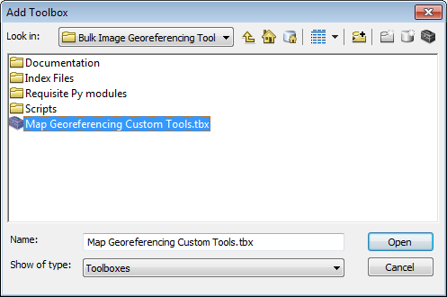

Once you press open, the toolbox “Map Georeferencing Custom Tools” should appear. You are now ready to use the scripts.

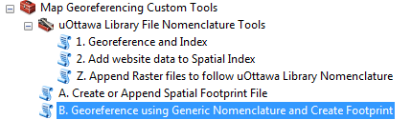

# Using the Scripts

## Z. Append Raster Files to follow uOttawa Library Nomenclature (use before Excel Indexing)

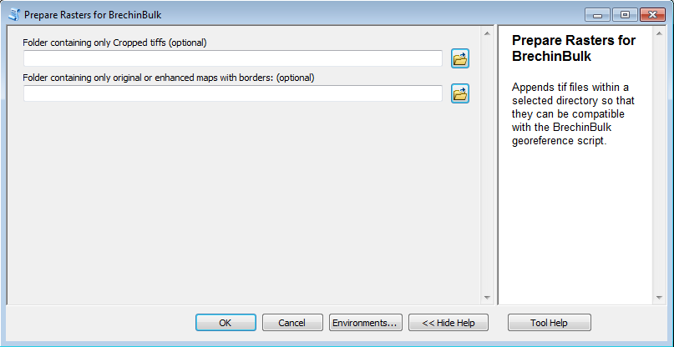

This is an **Optional** Script that changes the file names of the rasters for any archival project so that it works with the Brechinbulk tool. If your cropped rasters already end with “\_C.tif”, and your rasters with borders end with “\_W.tif”, you won’t need to use this tool

This script prepares entire folders (but not subfolders) for the special Georeferencing tool using uOttawa Library file nomenclature. It does this by appending the filenames of “.tif” rasters. It will append all rasters in the cropped raster directory with "\_C.tif". It will also change the rasters in the restored directory with “\_W.tif”.

To use this tool, place all of the cropped .tif rasters into a single folder and the rasters with borders into another. Select these folders. Press “OK”. After running this tool, ensure that the new file names are reflected in the excel spreadsheet.

## 1. Georeference and Index

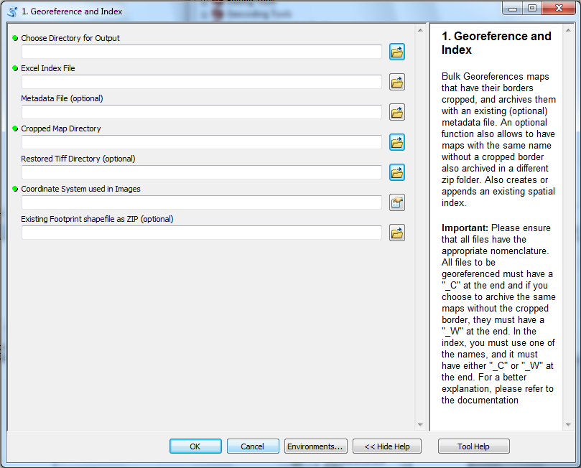

The “Georeference and Index” tool does several things: Using the Excel file index, it georeferences all borderless images within a certain folder. It zips these images in separate archive files, and packages them with (optional) metadata. Optionally, it also zips all the corresponding images with borders with the (optional) metadata. Finally, it creates a new spatial index feature class, or appends an existing one if selected.

To use this tool, the “Choose Directory for Output”, “Excel Index File”, “Cropped Map Directory”, and “Coordinate System” fields are mandatory. If you already have created a spatial index feature class and wish to update it, you can select it in the bottom field. All output files will appear in the selected output directory.

## B. Generic Georeference and Index

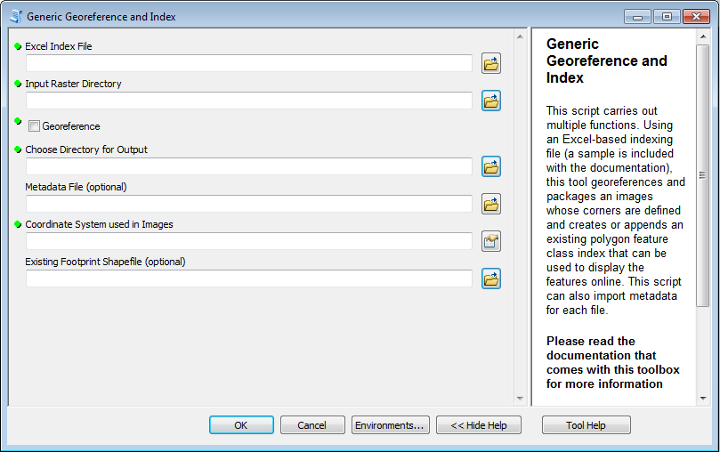

The “Generic Georeference and Index” tool is used when you are only interested in archiving a single series of maps or airphotos as opposed to the Brechinbulk tool, which is ideal when you want to georeference and archive cropped map rasters and archive a corresponding series of map rasters that still have their borders. The file nomenclature rules for the BrechinBulk tool don’t apply for this tool. Choose a folder, and make sure the file names match the ones on the excel index. You can choose to georeference the images, and you can package these images each with a metadata file. You can also choose to update an existing spatial index feature class if you’ve created one already from another tool in this set.

## A. Create/Append a Spatial Footprint File Only

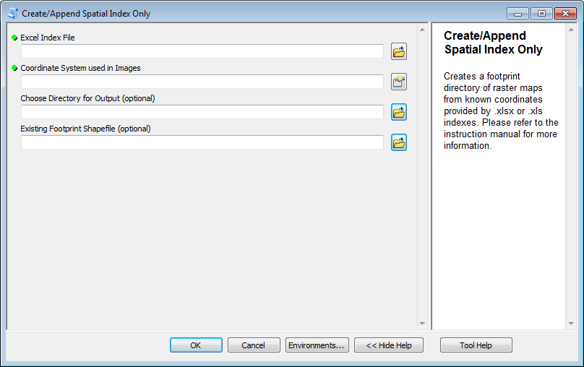

The “Create/Append Spatial Index Only” Tool is a stand-alone tool that takes all rows in the Excel index, and creates a shapefile that is appropriate for online use in places such as ArcGIS.com. This tool is ideal when you have not scanned your maps, but still want to spatially display your holdings.

# Frequently Asked Questions

**Q:** When I run this tool, the progress display continuously says that it is building pyramids. Is there something wrong?

**A:** No. This is one way that the tool shows that it is running properly. It will do this if the rasters are being georeferenced.

**Q:** When I ran the batch (.bat) file to install the necessary Python modules, I found that it ran really fast. Did something go wrong?

**A**: No, everything should have gone correctly. The installation process for each of the Python modules is fast.

# About the Scripts

The Scripts, index files, and all related material were created by Brian Bancroft as an employee of the University of Ottawa Library. This work is licensed under the Creative Commons Attribution-ShareAlike 4.0 International License. To view a copy of this license, visit <http://creativecommons.org/licenses/by-sa/4.0/>. To find more information about the University of Geographic, Statistical and Government Information Centre (GSG), visit <http://biblio.uottawa.ca/gsg> or email [gsg@uottawa.ca](mailto:gsg@uottawa.ca) . To contact the creator, visit <http://www.geographicinformationsolutions.ca> or email [Bancroft.bw@gmail.com](mailto:Bancroft.bw@gmail.com) . Quality Assurance was handled by Alexandre Billard who, at the time of publication, is an undergraduate student employed by the GSG, starting on a Comp Sci major and a Geomatics minor. This instruction manual was edited by Talia Chung, who is in charge of the GSG. A special thanks to Pierre Leblanc and Sarah Simpkin as they have both guided the direction of this project.